**Automotive Power Windows:**

In this model, an automotive power window system raises and lowers the passenger-side window in response to a pair of window control switches.

The switches in the MATLAB app represent the controls on the driver and passenger doors. The app also contains several indicator lamps that monitor the status of the power window system and a button for introducing an obstacle in the path of the window.

When you point a switch in the app to a new position, the chart sends a corresponding "Up," "Down," or "Neutral" command to the power window control system. Conversely, when the control system changes state, the chart enables or disables the corresponding status lamps in the app.

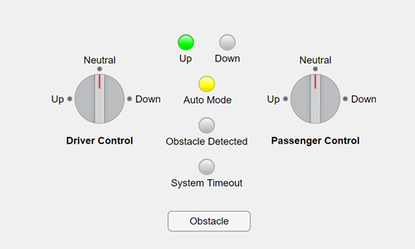

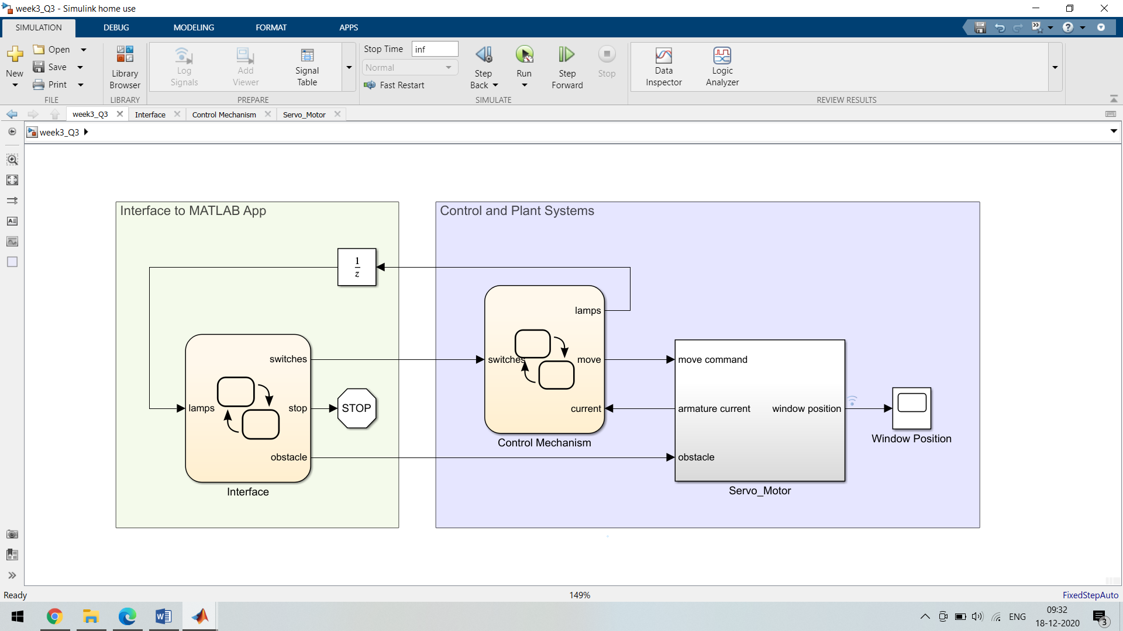

**Detect Obstacles:**

When the window encounters an obstacle, the applied force on the window increases the load on the servo motor and causes a rise in the armature current.

By monitoring for sharp increases in the armature current, the system detects obstacles in the path of the window.

Here, Simulink subsystem simulates the servo motor. And the position of the window is computed by an Integrator block with saturation limits of fully opened and fully closed. Because the input to this block has a gain of 2, the window opens and closes completely in 5 seconds, as specified by requirement 1. When the Integrator block reaches a saturation point, the system output armature current increases to 10. This value indicates that the window is fully open or fully closed.

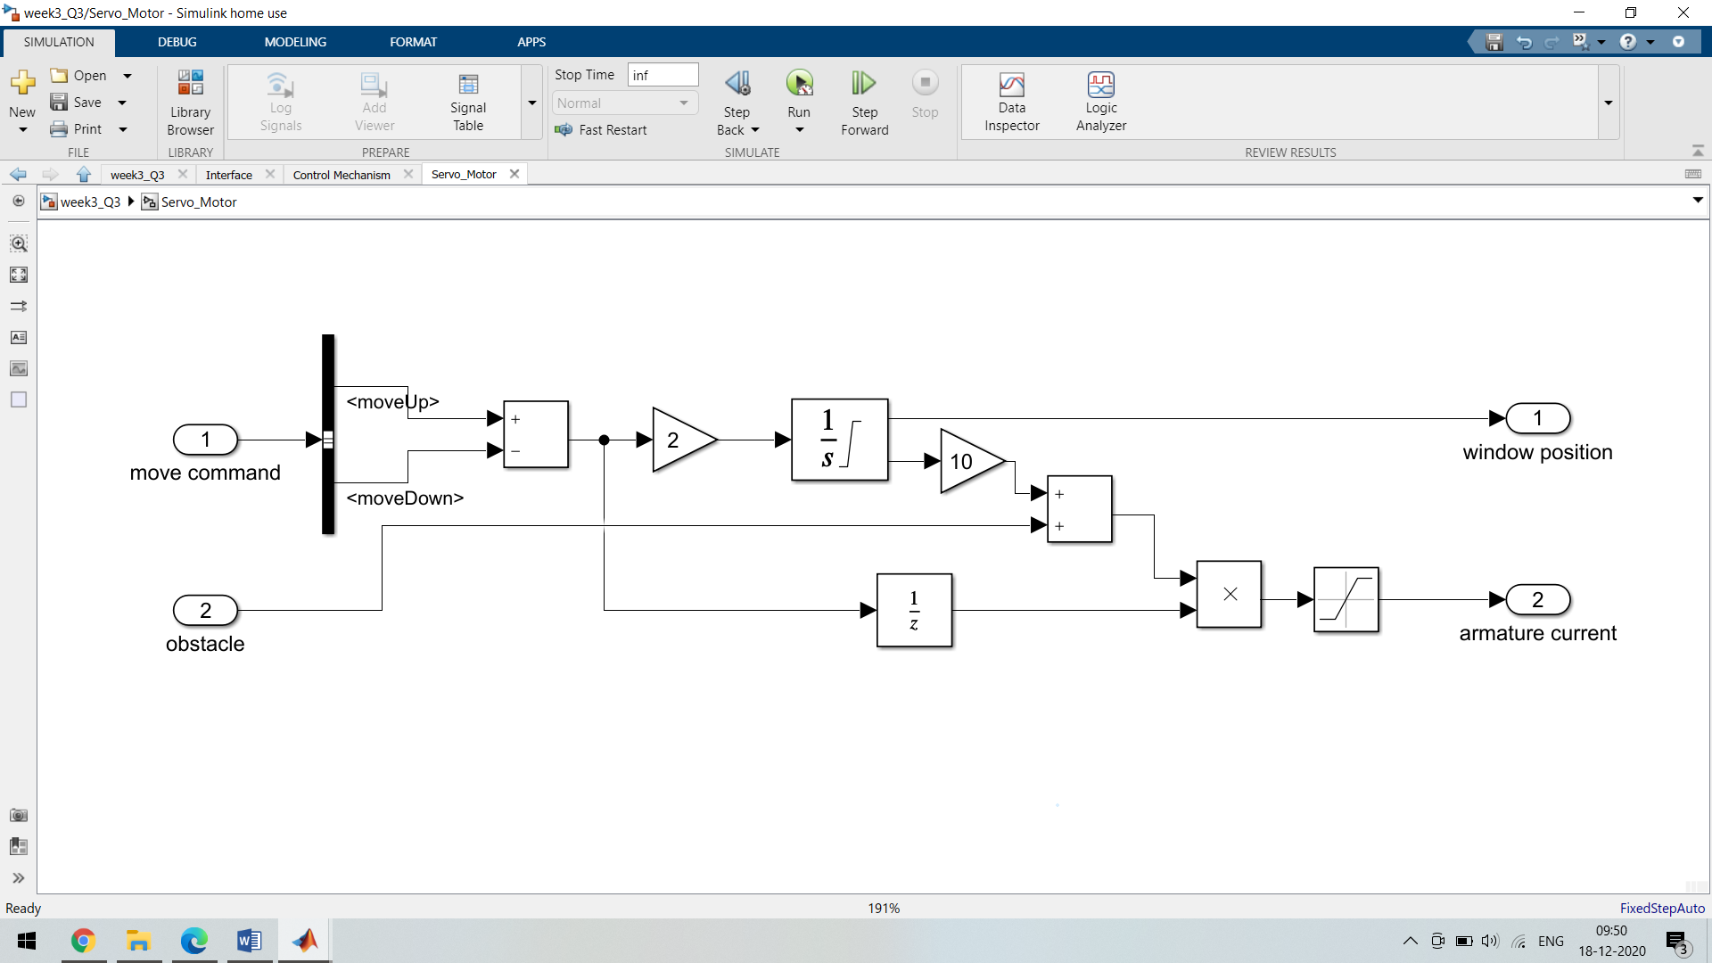

**Action Table:**

|  |  |  |
| --- | --- | --- |
| **Sr No** | **Description** | **Action** |
| **1.** | Move Upword | send(UP,Logic); |
| **2.** | Move Down | send(Down,Logic); |
| **3.** | Stay Neutral | send(Neutral,Logic); |

**Solver Selected:**

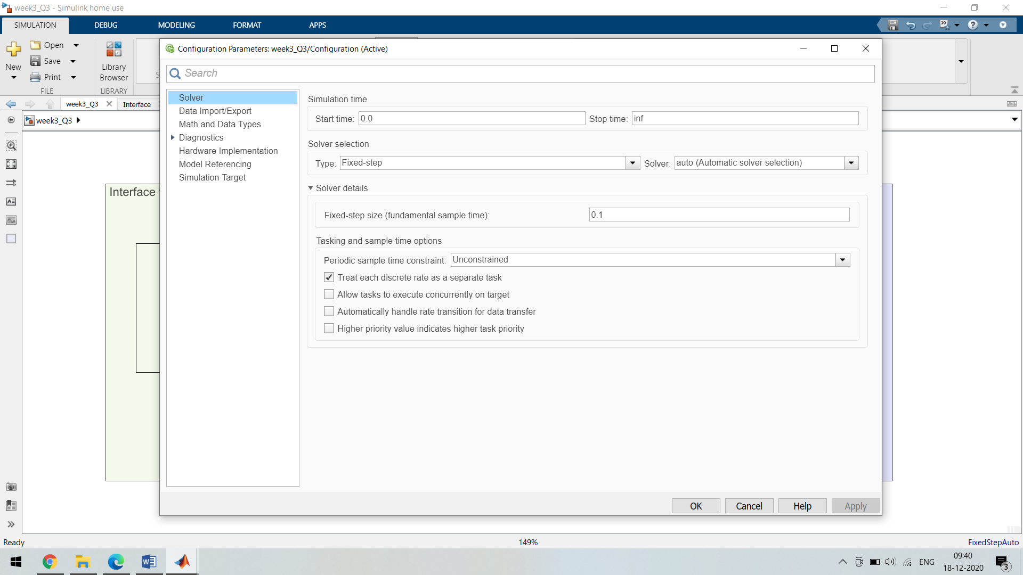

**Test Cases Table/Truth Table:**

|  |  |  |  |  |  |  |
| --- | --- | --- | --- | --- | --- | --- |
| **Sr No** | **Test Cases** | **D1** | **D2** | **D3** | **D4** | **D5** |
| **1** | If Driver moves window Upside | **1** | **0** | **0** | **0** | **-** |
| **2** | If Driver moves window Downside | **0** | **1** | **0** | **0** | **-** |
| **3** | If Passenger moves window Upside | **-** | **-** | **1** | **0** | **-** |
| **4** | If Passenger moves window Downside | **-** | **-** | **0** | **1** | **-** |